2. LITERATURE SURVEY

2.1 Review and History
This section shows the steps towards achieving the objective of detection of drowsiness and alcoholic intoxication. Detection of drowsiness can be done in several ways like remotely measuring the heart rate or facial expression of the person to be tested. This work is the combination of face detection, eye region detection and eye closing rate detection in real time environment.
OpenCV is open source software for creating computer vision related task and it is available as an extension for C, C++, Java and Python programming languages. Making a computer vision application in real time is a challenging task and it needs efficient processing power. Raspberry-pi is an ARM11 controller based small sized open source CPU with 512 MB RAM and supports 700 MHz processing speed.
It supports interfacing of various low level and high level peripherals including digital camera and GPIO’s. It can work with light weight Linux based operating system Raspbian which is loaded with Python-IDLE programming software. OpenCV linux version is installed to Raspberry-pi.
Alcohol's effect on both the fast and slow eye movement systems has been well studied (see Stapleton, Guthrie, & Linnoila, 1986, for a review with considerations of traffic safety). Alcohol intoxication slows the initiation and the velocity of saccadic eye movements and reduces the gain of slow eye movements (Moser, Heide & Kompf, 1998; Holdstock & de Wit, 1999). Gain is a ratio of eye velocity / target velocity and should be close to 1.0 to maintain fixation on the moving target.
With alcohol intoxication, the slow eye movements are too slow, gain is <1.0 and the visual system must recruit the fast eye movement to generate a "catch-up saccade." This produces the jerky eye movements, also called horizontal gaze nystagmus that are an important component of field sobriety tests (Forkiotis, 1986, Tiffany, 1986; Good & Augsburger, 1986; Belton 1987).
The specific effects of alcohol intoxication on visual perceptual performance are also well known. For instance, contrast sensitivity is affected by alcohol (Nicholson et al., 1995; Pearson & Timney, 1998) but visual acuity and colour vision remain largely unaffected by alcohol (Wallgren & Barry, 1970; Watten & Lie, 1996, Hill and Tofollon, 1990).
There remains controversy regarding alcohol's effect on depth perception from binocular stereopsis (Hill & Toffolon, 1990; Wratten & Lie, 1996). Wegner and Fahle (1999) suggest the discrepancy is due to large inter individual differences and floor effects in previous binocular stereopsis studies hiding the small changes caused by alcohol intoxication.

2.2 Performance Evaluation Parameters and Details
The four categories of driving behaviour are as follows
- Normal Behaviour
The driver behaviour is said to be normal when he (driver) concentrates on the driving task. This can be characterized by controlling the speed of the vehicle, avoiding of sudden acceleration, driving without alcohol intoxication.
- Drunk Behaviour
The behaviour is said to be in drunk, when the driver was intoxicated by alcohol and is characterized by a set of observable actions like sudden acceleration, driving without controlling the speed.
- Fatigue Behaviour
It stated that a driver driving after a period of 17 hours with no sleep behaves exactly as a driver who has 0.05% intoxication of alcohol. Based on this argument, fatigue driving was defined as driving that exhibits the same characteristics as drunk driving, but there is no alcohol intoxication in the blood of the driver.
- Reckless Behaviour
It is the behaviour of the driver who drives at high speed, with a high degree of acceleration and makes other traffic participants at risk. There is no alcohol intoxication and the driver’s eyes are open, but the following behaviours such as driving with sudden acceleration, not maintaining the proper lane position and not controlling the vehicle’s speed are exhibited.

    - Signs of Drowsy Driving
Sleepiness and driving is a dangerous combination. Most people are aware of the dangers of drinking and driving. The people don’t realize that drowsy driving can be just as fatal, for example: alcohol, sleepiness slows reaction time, decreases awareness, impairs judgment and increases your risk of crashing. There are many underlying causes of sleepiness, fatigue and drowsy driving.
It includes the sleep loss from the restriction, interruption or fragmented sleep; chronic sleep debt; circadian factors associated with driving patterns or work schedules; undiagnosed or untreated sleep disorders; time spent on a task; the use of sedating medications; and the consumption of alcohol when already tired. These factors have cumulative effects and a combination of any of these can greatly increase one’s risk for a fatigue-related crash.
There are many signs of the driver’s drowsiness:
    - Driver may yawn frequently.
    - Driver is unable to keep eyes open.
    - Driver catches him nodding off and has trouble keeping head up.
    - The thoughts of the person wander and take focus off from the road.
    - The driver can't remember driving the last few miles.
    - Driver is impatient, in a hurry, and grouchy.
    - The person ends up too close to cars in front of you.
    - The person misses road signs or drive past your turn.
    - Drift into the other lane or onto the shoulder of the road.

2.2.2 The requirements for an effective drowsy driver detection system are as follows:
    - A non-intrusive monitoring system that will not distract the driver.
    - A real time monitoring system, to insure accuracy in detecting drowsiness.
    - A system that will work in both daytime and night-time conditions.

    - Techniques for Detecting Drowsy Drivers
The techniques for driver drowsiness can be classified into different categories.
    - Sensing of physiological characteristics
    - Sensing of driver operation
    - Sensing of vehicle response
    - Monitoring the response of driver

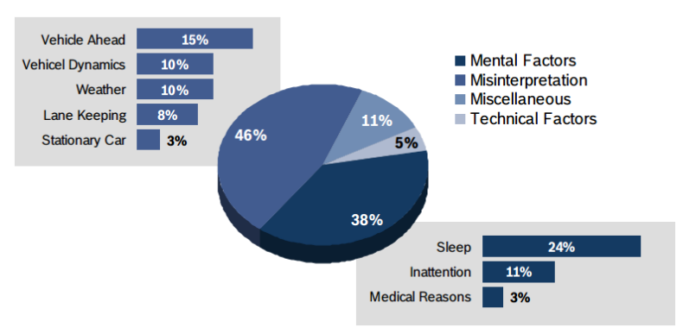
Figure 2.1: Reasons of Drowsiness

2.3 Various Systems
2.3.1 Design and Implementation of Driver Drowsiness and Alcohol Intoxication Detection
Fatigue and drowsiness of drivers are amongst the significant causes of road accidents. Factors like increased stress level in working environments, reduced sleep, variation in sleep pattern and time due to the adaptation of global time zone in working environments, increase in alcohol consumption, larger distance travel using high power automobiles contributes to increased level of driver drowsiness and fatigue which reduces driver perception level and decision making capability and hence negatively affect the ability to control the vehicle.
In the past decade, steep increase in accidents and loss of life was experienced mainly due to the increase in the driver drowsiness and fatigue. Drunk driving, or officially Driving under the Influence (DUI) of alcohol, is also a major cause of traffic accidents throughout the world. This paper proposes a novel approach for real time detection of driver’s drowsiness as well as alcohol intoxication and subsequently alerting them.
The aim is to reduce the number of accidents due to driver’s fatigue and alcohol intake to increase the transportation safety using Fatigue, Drowsiness detection, alcohol intoxication, Real time detection.
After understanding the problem statement and analyzing it I have come up with a solution whose operating scenario is shown in figure. Block diagram of the drowsiness and alcohol intoxication detection system, it basically consists of Processor i.e. Raspberry Pi board in this case, camera, alcohol sensor, buzzer and relay switch.
The heart of the system is Raspberry pi board through which all other modules such as camera and buzzer are connected.
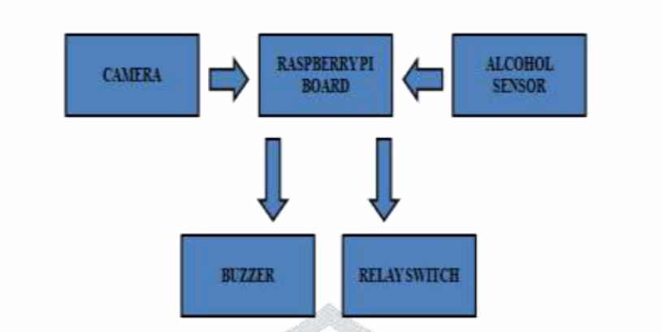
Figure 2.2: Block Diagram of the System

Basic concept is that detection of eye region is done using camera module which is connected to the raspberry pi board. On the other end alcohol sensor is connected to detect the alcohol intake of the driver. Based on the detection of drowsiness or alcohol intoxication an alarm will be generated through buzzer and car’s power source can be cut down through relay switch to stop the car.
This technique will not let the driver start the car in initial state if he has consumed alcohol. Hence the mentioned device provides solution to prevent accidents caused by drowsy driving and alcohol intoxication to a great extent.
This project is targeted to overcome the problems faced due to drowsiness while driving by drivers and preventing drivers to drive under the influence of alcohol. Hence the project provides solution to prevent accidents caused by drowsy driving and alcohol intoxication to a great extent. Mentioned device will provide alertness to driver if in case drowsiness is detected by the system and will switch off the ignition of the car through relay switch to prevent drunk driving.

2.3.2 Driver Behaviour Monitoring through Sensors and Tracking the Accident using Wireless Technology
Monitoring the driver behaviour is one of the ways to prevent the fatal accidents and it is necessary to alert the driver when they are drowsy or in a distracted state. Distraction and drowsiness of the driver have been important factors for a large number of major accidents.
They reduce the decision making capability and the perception level of the driver which negatively affect the ability of the driver to control the vehicle. A large number of serious or fatal accidents are occurred due to excessive or inappropriate speed of the vehicle and fatigue nature of the driver.
With the new developed systems (sensors) there is a possibility of self-controlling the vehicle when the driver was drunk or reckless or fatigue in order to reduce the major accidents. There is also a possibility of tracking the location of the accident, if occurs, through wireless access technology (GSM, GPS) so that proper measures are taken at a correct time driver Behaviour Monitoring using ARM, driver behaviour, GPS, GSM, MEMS.

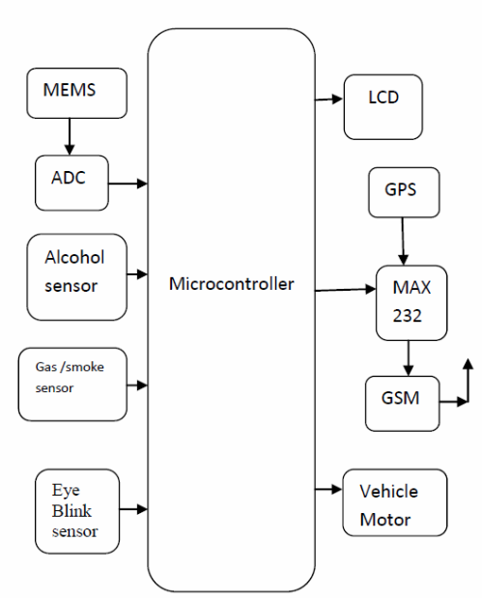
Figure 2.3: Embedded System Design

The Embedded system design consisting of MEMS-Micro electro mechanical system, GSM-global subscriber module, GPS-global position system, alcohol detector, eye blink detector, gas leak detector, fire detector. Most of the researchers tried to monitor the behavior of the vehicle or the driver in isolation, while others have focused on monitoring a combination of the vehicle, the driver and the environment in order to detect the status of the driver so as to prevent road accidents.
There is still no comprehensive system which can effectively monitor a driver’s behaviour, the state of the vehicle and changes of the environment. Alerting other vehicles on the road by sending warning messages to the relevant vehicles in the vicinity, includes some corrective actions to avoid accidents.

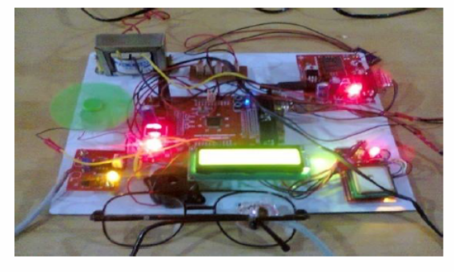
Figure 2.4: Research Experiment Picture of System

Working of the System and Operation
Different sensors (alcohol, gas, eye blink) are used to sense the alcoholic nature of the driver, any leakage of gas, the eye-lid movement of the driver. The output of different sensors is given to the microcontroller. The output of the microcontroller is displayed on the LCD. If any gas leakage occurs or when the driver is intoxicated with alcohol or if the driver blinks his eyes, immediately the motor of the vehicle will stop.
If the accident occurs by vibration of rotating machinery of the vehicle, immediately the exact location of the accident is identified by an authority person through Global positioning system(GPS)and message is sent via Global system for mobile Communications (GSM).
Detecting and monitoring the driver behaviour is vital to ensure road safety by alerting the driver and other vehicles on the road mainly in cases of abnormal driving behaviours. Behaviour of the driver is affected by many factors that are related to the vehicle, the driver and the environment.
It is important to capture the static and the dynamic aspects of behaviour and take into account the contextual information that relates to behaviour of the driver. Nowadays, different driving support systems assistant the driver in reaching his destination safely. In many cases, these systems capture sensory data and present them to the driver. These systems actually process the data captured by the sensors.
They act quantitatively relatively to the processed data. The growth of sensor technology and network based information technology has expanded the reach of wire-less sensor networks into numerous areas such as remote control, health care, monitoring of wildlife habitat, detection of military explosive, intelligent home monitoring and environment observation and forecasting system.

2.3.3 Driver Behaviour Analysis using Non-Invasive Sensors
Detecting driver distraction has been an important research topic over the past few years. While there are many common reasons for vehicle crashes, driver distraction and inattention are very prominent causes. Previous studies have shown the impact that inattentions can have on driving behaviour, which can lead to many crashes and fatalities. The study reported by The National Highway Traffic Safety Administration (NHTSA) indicated that over 25% of police-reported crashes involved inattentive drivers.
The 100-car Naturalistic Study concluded that over 65% of near crashes and 78% of crashes included inattention. These high percentages are not surprising, since 30% of the time drivers are in a moving vehicle, they are engaged in secondary tasks that are potentially distracting. These numbers are estimated to increase as the usage of in-vehicle technologies for navigation, communication and infotainment, and the number of cars on the roads is expected to exponentially increase in the next years.
A driver monitoring system that is able to sense inattentive drivers can play an important role in reducing the number of accidents, preventing fatalities and increasing the safety on roads. In this paper Monitoring driving habits of a person is presented, which is based on CAN network. The CAN bus is used as a communication of a distributed control network. This paper mainly introduces the design of the hardware and the software in detail. This device track speed, Engine temperature and Alcohol consumption status.

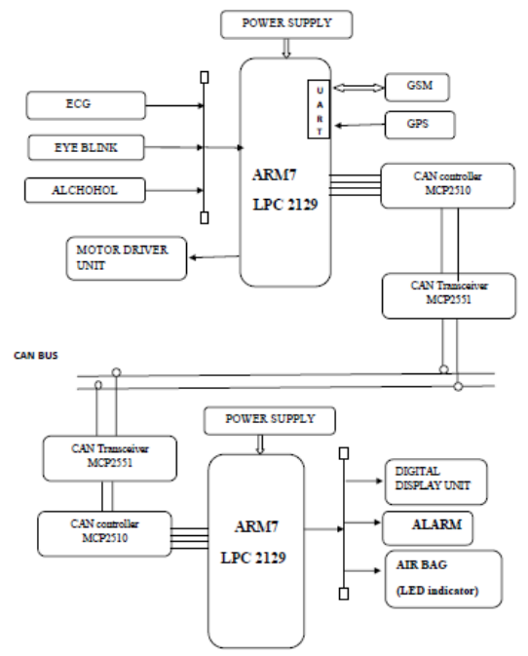
Figure 2.5: Working Modality of the Module
A real-world driving study inherently involves numerous uncontrollable variables such as traffic, weather and traffic lights which are not easily replicated in a simulated environment. This analysis aims to identify relevant features that are directly affected by the driver’s behaviours, and to use these features to quantify the distraction level of the drivers.
Before the motor can start the driver has to give the alcohol test. If any alcohol content is detected then the valve of the fuel tank will be closed. When no alcohol content is detected then the motor starts. While driving the sensors like eye blink and pulse sensors will monitor the eye blink and heart beat continuously.
If any abnormalities are detected then the accident preventive measures like the opening of the air bag, sounding the alarm system and indication using the side lights are taken. The vibration due to the crash by the other vehicle can be detected using the vibration sensor and if any vibration due to the crashes is detected, then the accident preventive measures are taken.
With the help of the CAN (Controller Area Network Bus the signals from a controller which monitors the driver’s behaviour and to which the sensors are interfaced is communicated to the other controller to which the external features are connected. In case the accident occurs then the message about the accident is given through the GSM technique. The position of the car is tracked using GPS (GLOBAL POSITIONING SYSTEM).
The output of the heart beat sensor is active high for each and every heartbeat and this can be given to the microprocessor. LED flashes for each heartbeat whenever sensor starts working. The sensor works on the basis of light modulation by blood flow through finger for each pulse.
Effect of Driver Behaviour
The secondary tasks force the driver to be distracted from the primary task which is driving. These distractions in the driver behaviour can be detected by using a series of sensors. The normal pulse rate of the human being is about 72 heart beats per second.
In case of any stroke or any other problems related to the heart beat then the count of the heart beat varies from the normal value. The range from 65 to 80 heart beats is considered to normal. If the pulse rate is not in this range then the driver’s behaviour changes due to the abnormalities.
The normal eye blink rate is about 15 to 20 blinks or lesser. When the driver is in drowsy state the number of blinks may increase than the normal level as the driver tries to come out of the drowsy state or the eye lids remain closed for a longer period than it is required for the normal eye blink.
The breath of the person who is not drunk does not contain any alcohol content or very minute traces of the alcohol. If the breath contains more than the allowed level of the alcohol content then it is concluded that the person is in drunken state.
The system proposed in the paper is a fully functional automatic mentoring system which is a step ahead of presently available in terms efficiency, accuracy and simplicity. The system is designed with an objective of minimizing road accidents that occur due to over speeding.
The algorithm used for position matching and subsequent speed limit extraction is the first of its kind relying on both GSM and GPS input signals, complementing each other and thus avoiding limitations of using them individually for position tracking.

2.3.4 Finger Vein Recognition Based Driver Authentication and Alertness System Using GSM
This paper outlines the real time embedded system application for driver authentication and alertness. Biometric systems are the best authentication systems that are used to identify a person. Finger vein authentication is the anti-forgeable. When a person wants to drive, will just press their finger in the biometric system. When the finger vein are match automobile get ignited, this will be keyless authentication system.
If the matching fails GSM get triggered on and transmits warming message. Same automobile has the facility to detect fatigue and intake of alcohol by the diver. GSM, camera and buzzers are interfaced with Raspberry pi.
Raspbian OS is loaded with python and open CV. Arduino is interfaced with alcohol gas sensor. This two embedded boards are bridged by I2C bus. Arduino will turn off the relay to ignition system using Finger vein authentication, KNN classifier, GSM, Fatigue, alcohol gas sensor, I2C, python, open CV, Raspberry pi, Arduino UNO.

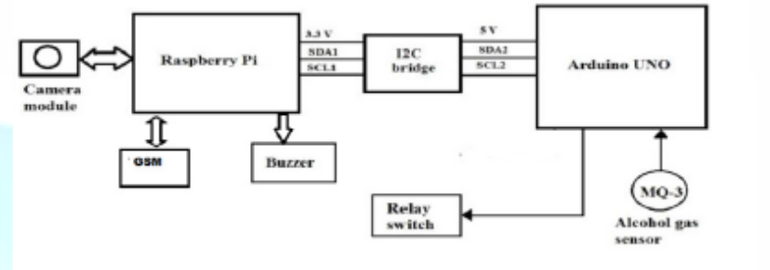
Figure 2.6: Block Diagram of Finger Vein Recognition Based Driver

Finger vein recognition is a newly found physiological and biometric behavioural that is used as an individual identic. A finger vein is a network of small vessels that located under the finger skin that it is invisible to naked human eyes. Finger vein can be viewed through an image sensor sensitive to near-infrared light with wavelengths between 700 and 1000 nanometres.
Recognition algorithm is show in figure. Finger vein recognition have three general stage image acquisitions, image pre-processing (cropping, resizing and enhancement) and identification process. Enhancement is used to reduce the noise that are present and it act as matched filter.
The feature extraction stage that is useful to find the minutiae. The minutiae are operated on thinned image and these are straightforward to detect. Finger vein image are thinned with image processing like resizing, cropping. PCA (principal component analysis) is one of the fundamental and very effective methods in terms of dimensional reduction. PCA is sensitive to the relative scaling of the original variables.

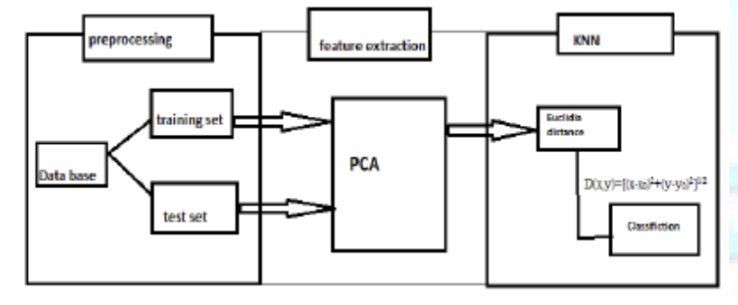
Figure 2.7: Block Diagram of KNN as Classifier in Vein Recognition

The K-nearest-neighbor (KNN) algorithm is an instance based learning method, figure shows KNN as classifier in vein recognition KNN measures the distance between a query scenario and a set of scenarios in the data set. Each sample in our data set has n scenarios of attributes which we combine to form an n-dimensional vector x={x1,x2,…,xn},y={y1,y2,…,yn}.
As discussed in this paper many technologies exist for biometric authentication, driver alcohol intake and drowsiness detection. This system is created with effective current technologies and software algorithm. There are few higher end cars having this technologies integrated but this is system is coat effective. The research is still in progressing state to develop into infancy mode. There is much to improve and work on in this system with current emerging techniques and use them.
Date base of finger vein image is collected free online data base, Human Identification using Finger Images [4]. Images are collected BMP format, Image 320 x 240 pixel sizes and converted into JPG. 100 finger vein images are collected from 5 persons, each 20 samples. 15 images are used for testing and other remaining images are used as training data base for a single Person.

2.3.5 Design and Development of Accident Prevention and Control System
In this paper, three basic circuits for prevention of accident and control measures are been explained. One is accelerometer circuit which is used for detection of drowsiness and second is alcohol sensor circuit which is used for detection and control of a vehicle due to alcohol consumption. Accident due to drowsiness can be prevented using alert mechanism which is controlled by relay when tilt motion is detected and it is sensed by single step accelerometer.
Similarly relay turnoff the ignition process of a vehicle if level of the alcohol is sensed above the normal by a sensor. Along with this brake failure detection is also done by checking the continuity if not the vehicle owner is made alert to prevent the accidents from brake failure Accelerometer, alcohol sensor.

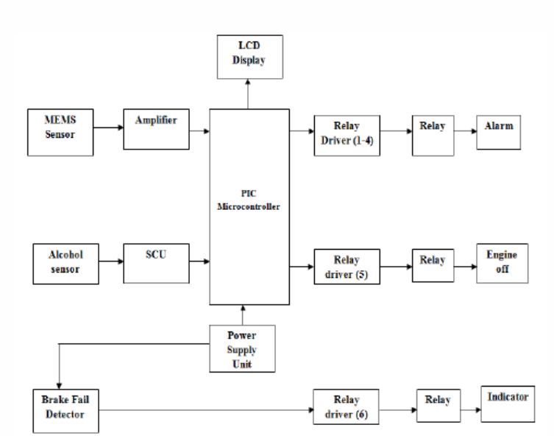
Figure 2.8: System Block Diagram

The block diagram of system is shown in the Fig 1. The system consists of MEMS sensor that is an Accelerometer, Alcohol sensor, Driver circuit, Relays, LCD display, Power supply, PIC Microcontroller, Brake failure detector. Alarm is used in a system to indicate regarding an emergency situation occurred. Alcohol Sensor is used to detect weather the person has consumed the alcohol or not.
Here MQ3 sensor is used as an alcohol sensor. An accelerometer is a device that measures proper acceleration or it is an instrument which is used for measuring the acceleration of vibrating or moving body. Microcontroller is used to perform various function and operations. Here PIC microcontroller is used. Brake fail is used in a system to indicate the brake failure in vehicle. SCU (Signal Condition Unit) signal conditioning means it will manipulate the signal in such a way that it meets the need of next stage for further processing.
Here the system is designed to detect the alcohol consumption and drowsiness of a person and also brake failure in a vehicle. As alcohol consumption is increasing within the youth so the accidents are increasing day by day.
When a person drinks and drives he may not have a presence of mind and most of them loose the control on a vehicle that he drives. So we are using an alcohol sensor which will detect the smell of alcohol. This will generate a voltage which is a weak signal. So we are using SCU (Signal Condition Unit) to boost up the signal. This signal is passed to PIC Microcontroller. This will perform two tasks. First it will display the information on LCD and secondly it will operate the corresponding relay which will turn off the engine automatically.
The software used is MPLAB IDE and PICkit3. MPLAB IDE is a software Program that run on a PC to develop applications for Microchip Microcontrollers and digital signal Controllers. It is called an Integrated Development Environment (IDE), because it provides a single integrated environment to develop code for embedded microcontrollers.
The features of MPLAB IDE provides a new call Graph for navigating complex code, Supports Multiple Configurations within Projects, Supports for multiple debug tools of the same type. And in PICkit3 it allows debugging and programming of PIC microcontrollers Using powerful graphical user interface of the MPLAB IDE.
This PICkit3 is connected to the design engineer’s PC using a full speed USB interface and can be connected to the target via a Microchip debug (RJ-11) connector. The features such as Real-time execution, Supports low voltage to 2.0 volts (2.0 to 6.0 range), Erase of program memory space with verification.
The outcome of project is basically has three applications one is to prevent and control the vehicle from the accidental situations due to drowsiness, second is to detect the drunk drivers through alcohol sensors which does not allow driver to start the vehicle and third is to indicate the brake failure of an vehicle and using microcontroller it displays the information on LCD.

2.3.6 Enhance the Driver Drowsiness Detection System Using EDAMAS and Region Prop Techniques
Safe driving is a major concern of societies all over the world. Thousands of people are killed or seriously injured due to drivers falling asleep at the wheels each year. Hence driver drowsiness is the major issue behind accidents. To solve this issue many techniques are used. In our paper, we are going to use the region prop with EDAMAS. In Driver drowsiness detection system region prop will helps to detect the size of eyes, whereas EDAMAS is used to detect the swelling of soft tissues using Driver Drowsiness, Region prop, Accident, EDAMAS.

Proposed Work
The various methods available to determine the drowsiness state of a driver. But because of the various definitions and the reasons behind them were discussed there is no universally accepted definition for drowsiness, all works discuses about the various ways in which drowsiness can be manipulated in a simulated environment. The various measures used to detect drowsiness include the subjective, vehicle-based, physiological and behavioural measures. The accuracy rate of using physiological measures to detect the drowsiness is high. These measures are highly intrusive. The intrusive nature can be resolved by using contactless electrode placement.
The development of technologies for detecting or preventing drowsiness at the wheel is a major challenge in the field of accident avoidance systems. Because of the hazard that drowsiness presents on the road, methods need to be developed for counteracting its affects. To overcome these researchers developed lots of techniques like a prototype drowsiness detection system. The focus was placed on designing of system that was accurately monitoring the open or closed state of the driver’s eyes in real-time. The symptoms of driver fatigue can be detected by monitoring the eye movement. It helps to avoid the accidents. Detection of fatigue involves the sequences of images of a face. It also observes the eye movements and blink patterns.
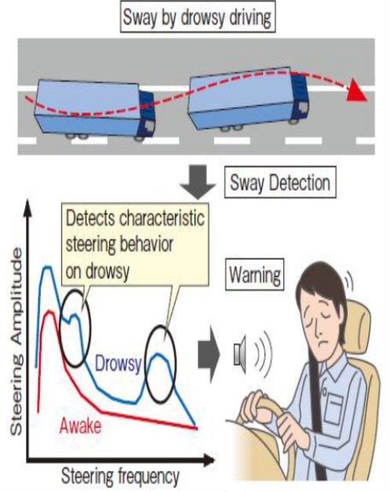
Figure 2.9: Drowsiness of Driver

EDAMAS: it’s a technique used to detect the swelling of soft tissues. As we know that during drowsiness our eyes gets swelled. So here we are going to use EDAMAS technique so that it can detects that drowsiness swelling of eyes of driver and can gives alarm. Here we will merge both techniques and develop a new Driver drowsiness detection system.
For the proposed work our objectives are:
    - Introduce the novel approach for preventing driver drowsiness.
    - Accurately measure are the symptoms of drowsiness like:
    - Case when the driver’s head is tilted.
    - Finding the top of the head correctly.
    - Finding bounds of the functions.
    - Implement the novel approach in simulation environment.
This is used for car safety. It is a technology which prevents accidents when the driver is getting drowsy during driving. This system detects driver’s eyes, face or body moment and gives alarm to wake driver. Now days some of the Driver drowsiness detection systems learn driver patterns and can detects when a driver is becoming drowsy means basically this system is used for safety of driver. Here to detect Driver drowsiness we are going to use a new scenario. In this proposed scenario we are going to use “region props” and “EDAMAS” techniques.

